SoundCite Assignment Template

The goal of this assignment is to explore how we might tell stories using sound and prose. To do this, we will use a tool developed by Northwestern's Knight Lab, SoundCite. SoundCite allows users to load a piece of audio directly into a text, enabling a reader to become a listener in just a few clicks. The instructions can be a bit complicated, and you might hit some snags and difficulties. Fear not! The goal is to experiment and practice. All the while, think about how any difficulties raise questions for you about what it means to apply digital technologies to humanities questions of time and space.
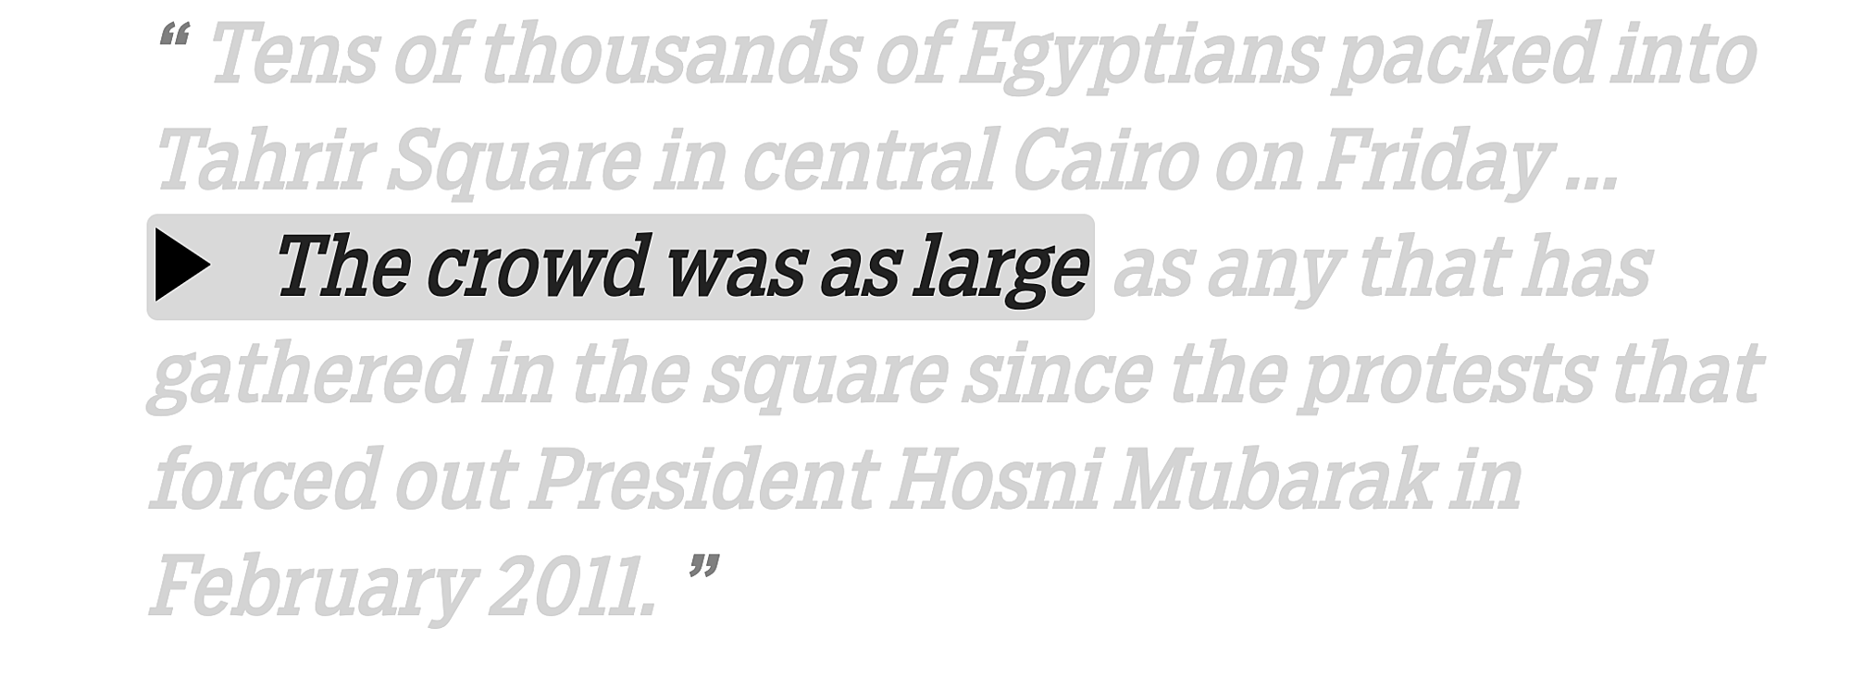
SoundCite Requirements
- You'll need an MP3, M4A, WAV or Ogg audio files. You'll need to upload it to a public webserver, and have a shareable URL.
- If you want to use the entire audio file, you don't have to do anything. If you want to play just a trimmed clip, you can enter the start and end times in the fields below.
- Once you're finished, you can embed the SoundCite link directly into your text.

Using SoundCite
- At the top of the SoundCite website, click on "make a Clip." Follow the requirements above.
- Proceed through the prompts by adding a URL to the audio clip.
- When your clip is complete, share embed the embed code in the appropriate spot in your text.

Cal Murgu, Brock University

